**Programming ESP8266 via NodeMCU devkit (SP12E v2)**

1. In Arduino IDE go to File -> References
2. Add Additional Boards Manager URLs "http://arduino.esp8266.com/stable/package_esp8266com_index.json" without quotation, if other URLs are present separate them with comma (,)
3. Click ok
4. Open Tools -> Board -> Boards manager find esp8266 install version 2.3.0 it will work with ESP Devkit (NodeMCU) version 2
5. Close Boards manager and select Board: NodeMCU 1.0 (ESP-12E module)
6. Set Frequency to 80MHz Upload speed to 115200 and select the port which ESP module is mounted
7. You are good to go.
8. You can use examples for ESP module find the blink to test the module

**Programming ESP8266 using USB serial converter(FTDI)**

For programming ESP8266 via FTDI cable or any FTDI device(including Arduino) you first need to install driver for FTDI from <http://www.ftdichip.com/Drivers/D2XX.htm> select your OS and download it. For windows I suggest you to download executable setup file and run as administrator

After installing the driver connect the FTDI to ESP8266 please make sure that FTDI support 3.3V if it is 5V device use voltage divider to make VCC 3.3V

|  |  |
| --- | --- |
| FTDI | ESP8266 |
| TX | RX |
| RX | TX |
| VCC | VCC |
| VCC | CH_PID |
| GND | GND |
| GND | RST via Button |
| GND | GPIO0 via Switch |

Install the ESP library like previous topic (steps 1-3) then just select Generic ESP8266 module.

Make sure FTDI connected to the computer before programming!!!

For programming

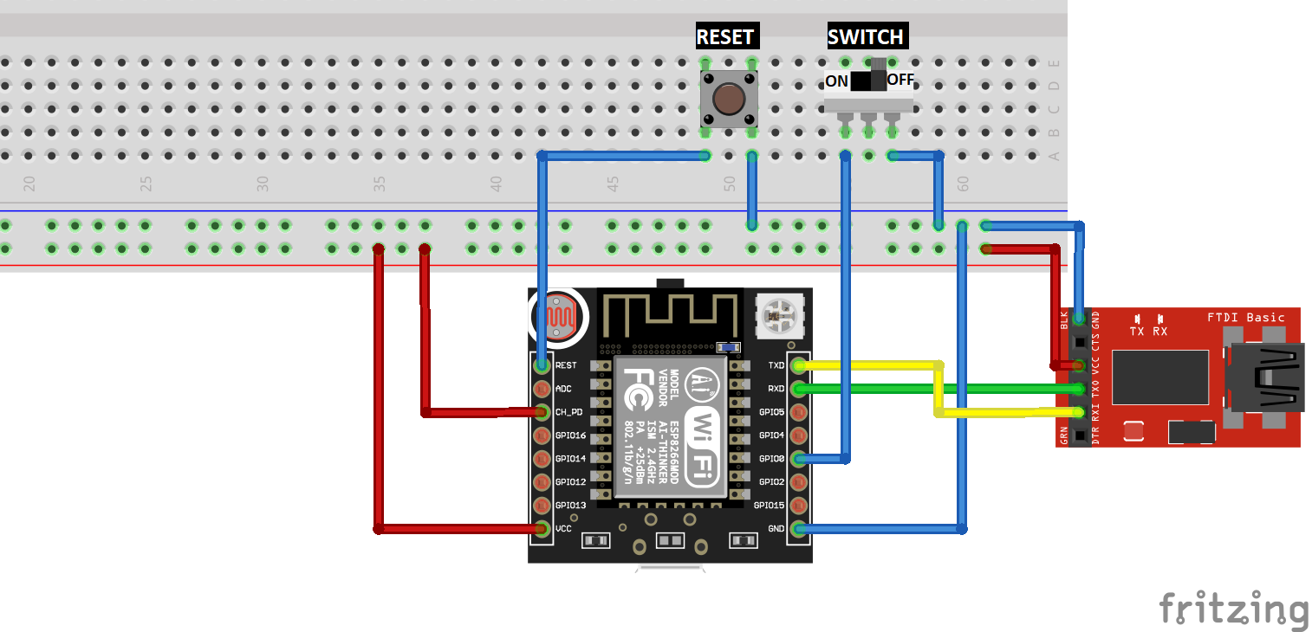

1. Set switch to on then push reset and upload the program
2. Set switch off and push reset
3. Now program will run

Halit Yagar

E-mail: halityagar45@gmail.com

Tel:5368903294

Version 1.0